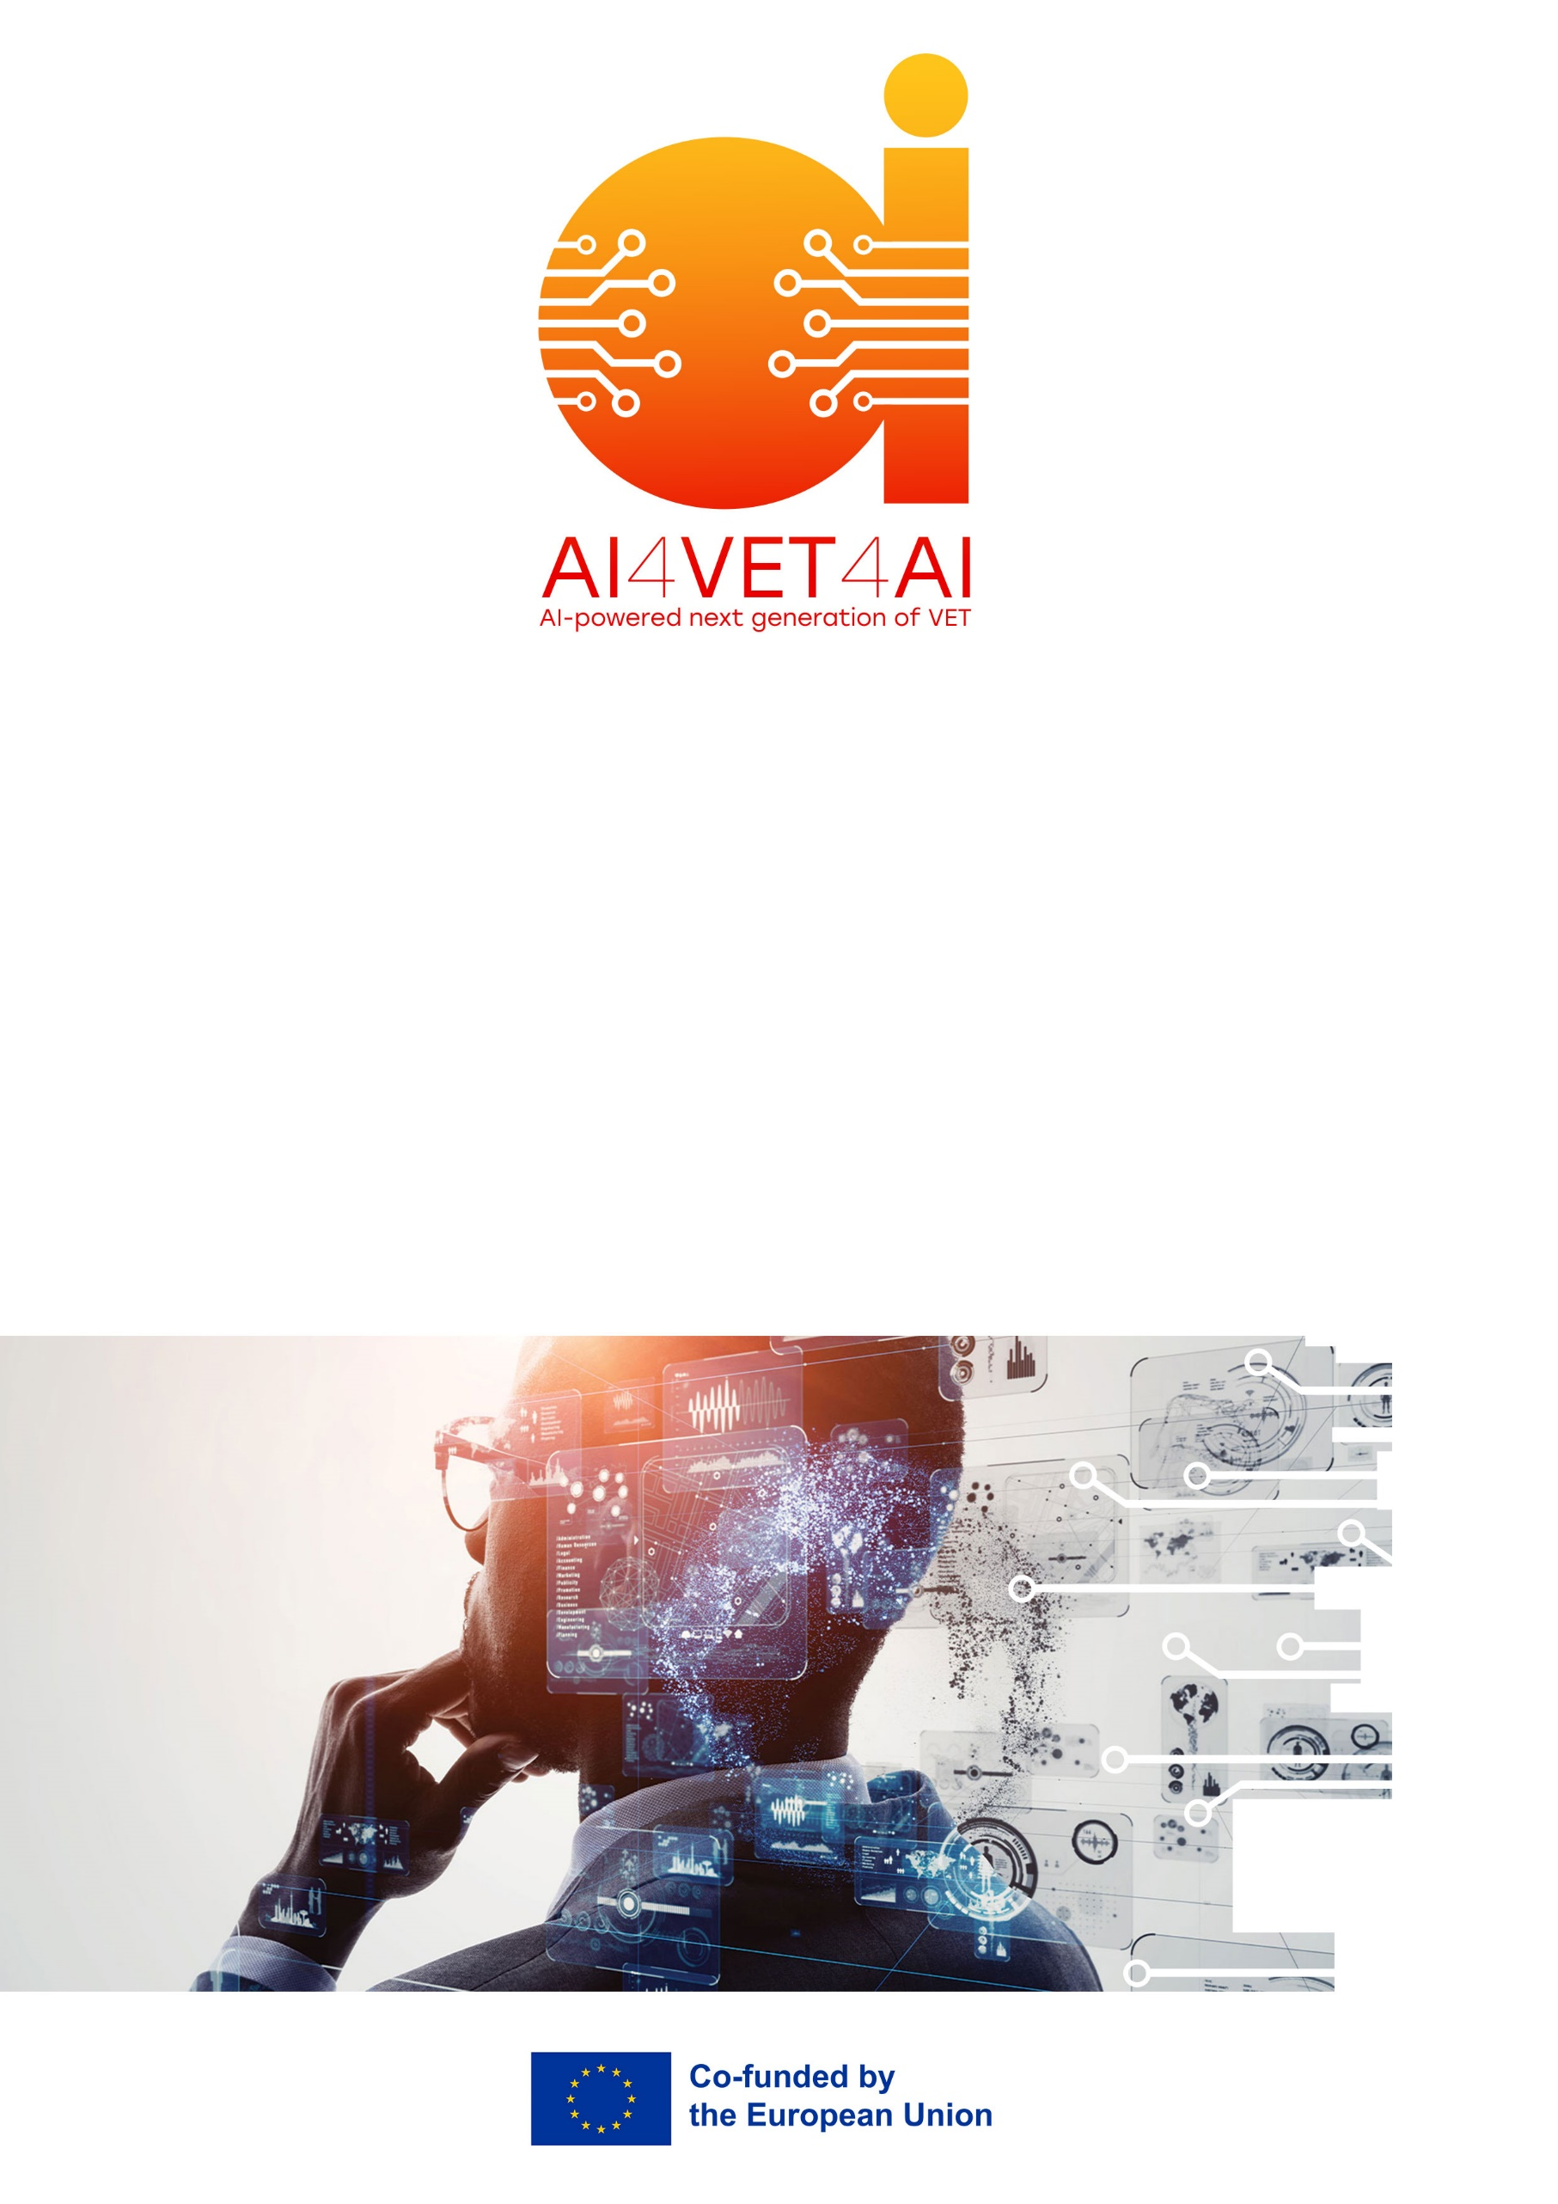
AI-Enabled Inventory Improvement in an SME Aviation MRO Environment
AI4VET4AI
AI-powered Next Generation of VET

Project 101104579

LEGAL NOTICE
The information and views set out in this report are those of the authors and do not necessarily reflect the official opinion of the European Union. Neither the European Union institutions and bodies nor any person acting on their behalf may be held responsible for the use which may be made of the information contained therein.

© AI4VET4AI Consortium, 2023
Reproduction is authorised provided the source is acknowledged.

Start date of project: 15 June 2023 Duration: 48 months

TABLE OF CONTENTS

1 Course information 3
1.1 Course name: AI-Enabled Inventory & Supply Chain Transformation Project 3
1.2 Learning outcomes: 3
1.2.1 Module 1 3
1.2.2 Module 2 3
1.2.3 Module 3 3
1.3 Project overview 3
1.3.1 Project title: AI-Enabled Inventory Improvement in an SME Aviation MRO Environment 3
1.3.2 Driving question or problem: 3
1.3.3 Project description: 3
2 Instructions 3
2.1 Instructions for students: 3
2.2 Instructions for teachers or mentors: 4
2.3 Supporting materials and tools: 5
2.3.1 Software 5
2.3.2 Course materials 5
2.4 Additional rules and restrictions: 5
3 Report and presentation 5
3.1 Presentation format: 5

Course information

Course name: AI-Enabled Inventory & Supply Chain Transformation Project

Learning outcomes:

Module 1
- explain the role of AI in supply chain operations,
- identify areas where AI can enhance inventory forecasting,
- demonstrate real-world cases of AI applications.

Module 2
- build a simple ML model for demand forecasting,
- design a basic data pipeline for an AI-driven inventory system,
- propose an integration concept for AI tools within existing inventory systems.

Module 3
- assess how AI supports supply chain optimization,
- analyze digital security risks and transaction anomalies,
- compare real AI-enabled industry case studies to the selected scenario.

Project overview

Project title: AI-Enabled Inventory Improvement in an SME Aviation MRO Environment

Driving question or problem:
How can a small aviation MRO organisation improve its inventory performance using AI-supported analysis of an unpredictable, safety-critical spare-parts environment?

Project description:
Students will complete an applied project in which they analyse a simulated inventory management situation and propose a comprehensive AI-driven improvement plan. Case study and data-set to be provided.
The final result includes a written report + a technical prototype/demo + a short reflection.
The project draws on concepts from all MOOC units: forecasting, optimisation, data pipelines, system integration, security, and case study analysis.
Deliverables include:
a written project report (15-20 pages), a technical component (prototype/model/pipeline), an oral presentation, a reflection.
Total expected workload: ~50 hours (2 ECTS).

Instructions

Instructions for students:
- SkyTech Aero Services is a relatively small aviation MRO organisation. It maintains light aircraft and helicopters, experiences highly variable demand consisting of planned maintenance and unscheduled parts demand, following aircraft inspection. Skytech is usually subject to long and inconsistent lead times for critical safety-related components. Review the case study and the dataset provided.
- Analyze the current inventory process. Identify workflows, pain points, KPIs, inefficiencies, and data gaps.
- Identify AI opportunities. Based on content from Modules 1-3, describe how AI could improve:
  - forecasting,
  - stock optimisation,
  - supply chain visibility,
  - demand planning,
  - fraud/anomaly detection.
- Set up a focus group of 3-5 relevant representatives and test your identified opportunities.
- Develop a technical component. Pick one of the following:
  - a simple demand forecasting ML model,
  - a data pipeline diagram,
  - a simulation of inventory optimization,
  - an integration prototype (conceptual or basic code),
  - an open-source tool demonstration.
- Prepare a 15-20 page written report. Follow the required structure (see below).
- Prepare a 5-minute presentation Summarize the problem, solution, results, and expected business impact.
- Write a 1-2 page reflection: explain what you learned, what challenges you faced, and how you see AI shaping the industry.

Instructions for teachers or mentors:
- Guidance: Provide students with case study and associated database ( 2,000 lines+, unique part ID, cost, lead-time, stock category, criticality, shelf-life, unit of measure, weight/dimensions, OEM or alt) , example templates, and recommended tools.
- Monitoring: Schedule one check-in session mid-way through the project. Verify that the student:
  - understands fully the scenario,
  - defined realistic data,
  - has a feasible plan for the technical element.
- Evaluation: Assess deliverables using the grading rubric:
  - Written Report 50%
  - Technical Element 25%
  - Presentation 15%
  - Reflection 10%
- Provide feedback focusing on:
  - correctness and depth of AI methodology,
  - quality of analysis,
  - clarity of the proposed improvements,
  - critical thinking in reflection.

Supporting materials and tools:
Students will be provided with:
- A complete case study describing SkyTech Aero Services, an SME aviation MRO organisation.
- A synthetic aviation MRO dataset designed to reflect intermittent demand, failures, lead-time variability, and stockout behaviour.
- A short data dictionary explaining each field and how it is used in analysis.

Software
- Optional analysis tools such as Excel or Power BI (no coding required).
- Access to approved Gen-AI tools (e.g., Copilot or ChatGPT) for summarising patterns, generating insights, and supporting interpretation.

Course materials
- All MOOC video lectures, notes, and demos
- AI models and examples provided in units 1-9
- Case studies from Module Sample cases. For example,
- https://www.intechgroup.co.uk/business/7-great-examples-of-how-ai-is-helping-small-businesses/
- https://www.impactanalytics.ai/blog/best-practices-in-demand-planning-and-forecasting
- https://www.flowlity.com/resources/ai-powered-demand-planning-software-small-businesses
- https://www.shopify.com/ca-fr/case-studies/doe-beauty
- https://www.prediko.io/case-studies/makerflo

Additional rules and restrictions:
The project may be individual, or completed in teams of 2-3 students, depending on instructor preference. Each member’s contribution must be clearly stated.
Use of AI tools (ChatGPT, Copilot, etc.) permitted for brainstorming, debugging code, summarizing content. Not permitted for: generating the full report, replacing student’s analytical work.
Students must declare all AI assistance used.
Sources and citation: All external sources must be properly cited (APA, MLA, or IEEE). Use only openly available or instructor-provided data.
Time frame: Suggested project duration: 3-4 weeks. Deadlines defined by course instructors.

Report and presentation

Presentation format:
A. Written Report (15-20 pages)
- PDF or Word (.docx)
- 1.5 spacing
- 11-12 pt font (Calibri, Arial, or similar)
- Professional headings and consistent formatting
- Recommended structure:
- Executive summary
- Description of selected company or scenario
- Analysis of existing inventory processes
- AI opportunity mapping
- Forecasting model or technical prototype
- Data pipeline and integration design
- Security and risk analysis
- Case study comparison
- Expected KPI improvements and cost-benefit analysis
- Conclusion
- References
- Appendices (models, diagrams, code excerpts)
B. Presentation (8-10 minutes)
- PowerPoint, Google Slides, or PDF
- 8-12 content slides
- Must include: problem definition, AI-based solution, technical component demo or results, expected business impact, reflection on learning.

