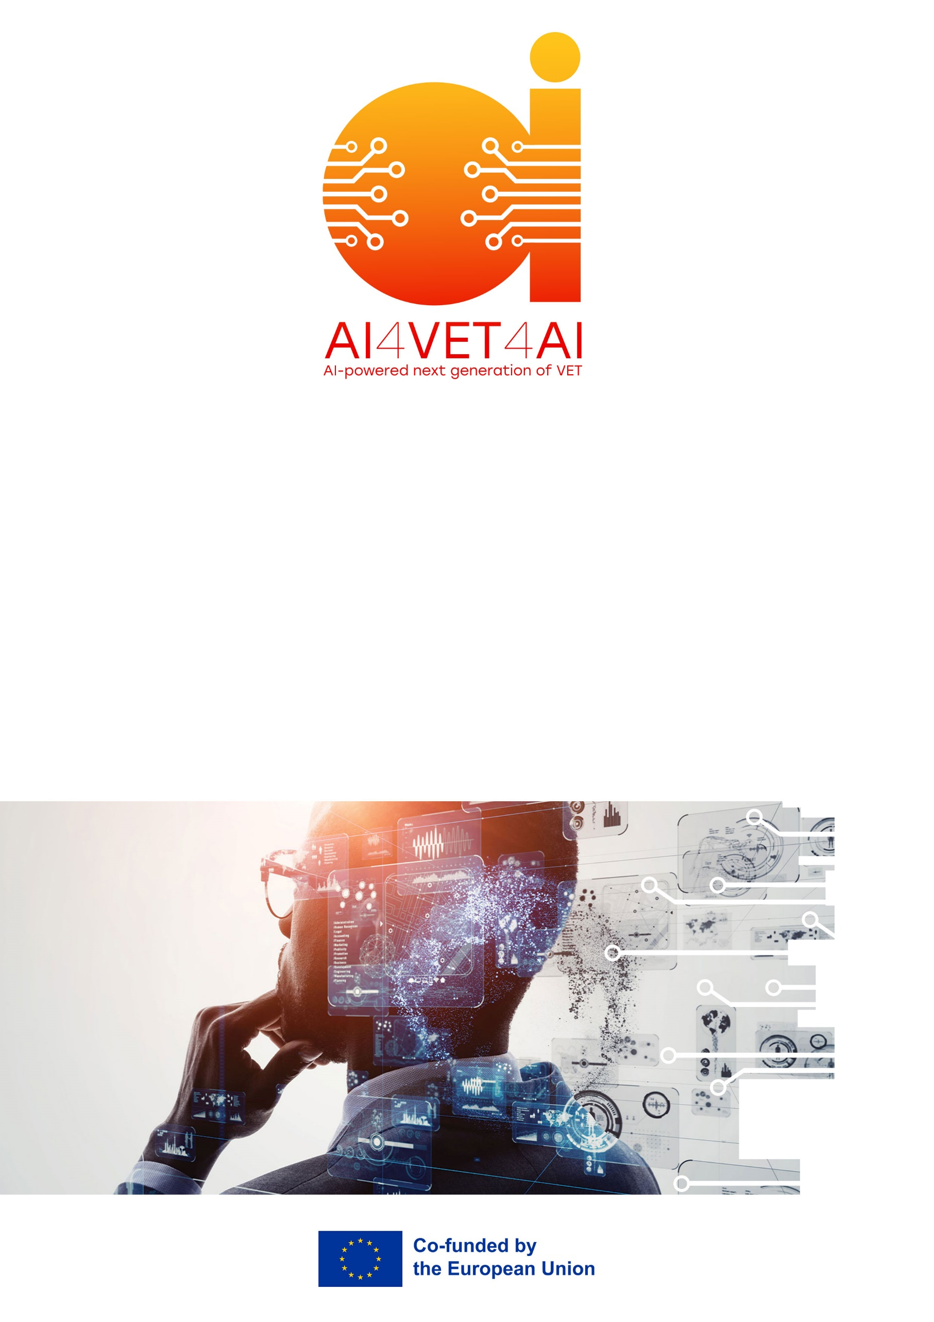
Optimising Doctor-Patient Interaction through AI-Mediated Communication
AI4VET4AI
AI-powered Next Generation of VET

Project 101104579

LEGAL NOTICE
The information and views set out in this report are those of the authors and do not necessarily reflect the official opinion of the European Union. Neither the European Union institutions and bodies nor any person acting on their behalf may be held responsible for the use which may be made of the information contained therein.

© AI4VET4AI Consortium, 2023
Reproduction is authorised provided the source is acknowledged.

Start date of project: 15 June 2023 Duration: 48 months

TABLE OF CONTENTS

1 Step-by-step project instructions for students 4
1.1 Phase 1: Problem Definition & Case Selection (Approx. 6 hours) 4
1.2 Phase 2: Literature Review & Baseline Analysis (Approx. 10 hours) 4
1.3 Phase 3: AI Tool Evaluation & Selection (Approx. 10 hours) 4
1.4 Phase 4: Designing the AI-Supported Interaction Workflow (Approx. 12 hours) 4
1.5 Phase 5: Ethical Impact & Trust Audit (Approx. 10 hours) 4
1.6 Phase 6: Final Report Synthesis (Approx. 12 hours) 5
2 Part 2: Instructions for Teachers and Mentors 6
2.1 Final Project Submission Requirements 6
2.2 Assessment Rubric 6
3 Annexes 8
3.1 Annex 1: AI Tool Selection Template 8
3.2 Annex 2: Comprehensive Project Quality & Ethical Checklist 9
3.2.1 Section 1: Clinical Problem Analysis & Context 9
3.2.2 Section 2: AI Solution Design & Technical Logic 9
3.2.3 Section 3: Workflow & The "Human-in-the-Loop" (HITL) 9
3.2.4 Section 4: Ethical Scrutiny & Trust (The "Black Box" Audit) 9

Individual Capstone Project: Optimising Doctor-Patient Interaction through AI-Mediated Communication
Course Information
Course Name: Supporting Doctor-Patient Interactions with AI
ECTS: 2 (Approx. 50–60 hours of individual workload)
Target Audience: Vocational and Higher Education students in Healthcare/Medical Informatics.
Format: Individual Problem-Based Learning (PBL) Task. Final Report to be 2000 words (+- 10%)
Project Overview
Project Title: Optimising Doctor-Patient Interaction through AI-Mediated Communication.
Guiding Question: How can an individual practitioner integrate specific AI tools into a clinical workflow to bridge communication gaps (language, literacy, adherence) without compromising patient trust or ethical autonomy?
Project Description: In this capstone, you will act as a "Clinical AI Integration Specialist." You are required to select a specific clinical scenario, such as a chronic disease clinic, a multilingual emergency department, or a care facility, and design a comprehensive communication strategy. You must demonstrate how AI (NLP, Chatbots, and Generative Imaging) can solve identified communication failures while maintaining a "human-in-the-loop" approach.
Learning Outcomes
Upon completion of this project, the student will be able to:
- Identify and classify communication barriers (language, health literacy, cognitive load) in a clinical setting.
- Evaluate and select appropriate AI technologies (CDSS, NLP, GenAI) to support patient engagement and medical adherence.
- Design a functional workflow that integrates AI tools into the doctor-patient interaction journey.
- Conduct a rigorous ethical audit focusing on non-maleficence, transparency, the "black box" problem, and patient consent and autonomy.
- Synthesize technical and ethical findings into a professional 2,000-word implementation report.

Step-by-step project instructions for students

Phase 1: Problem Definition & Case Selection (Approx. 6 hours)
Select a specific medical context. You may choose one of the following or propose your own after consultation with teachers:
- Scenario A: A clinic managing elderly patients with low medical adherence for hypertension.
- Scenario B: A maternity ward serving a high percentage of non-native speakers (language barriers).
- Scenario C: A surgical unit where patients struggle to understand complex procedural risks (health literacy).
Deliverable: A 300-word "Problem Statement" identifying the specific communication breakdown you aim to solve. This will help with initiating the writing process and also ensures that the report stays in scope of the project.

Phase 2: Literature Review & Baseline Analysis (Approx. 10 hours)
Utilize the provided reference documents (Unit 1, Unit 2, and "Challenges with Medical Adherence") to establish the baseline.
Tasks: Analyze why and how traditional communication (human-to-human) is failing in your chosen scenario.
Key Focus: Reference and contextualize the statistic that 27% of malpractice involves communication failures.
Deliverable: A summary table of current barriers vs. desired outcomes.

Phase 3: AI Tool Evaluation & Selection (Approx. 10 hours)
Consult the "Scope of AI Tools" and "Generative AI for Medical Procedure Image Generation" documents.
Tasks: Select at least two AI technologies to implement.
Example: Use NLP/Speech Recognition for automated clinical notes + Multimodal GenAI for personalized patient diagrams.
Evaluation: Justify why these tools are superior to traditional methods (e.g., speed, personalization, or translation accuracy).

Phase 4: Designing the AI-Supported Interaction Workflow (Approx. 12 hours)
Create a visual "Patient Journey Map" that spans three stages:
- Pre-Consultation: (e.g., AI Chatbots for symptom checking/translation).
- During Consultation: (e.g., Real-time NLP for documentation or GenAI for procedure visualization).
- Post-Consultation: (e.g., AI-driven medication planners and reminders).
Deliverable: A visual flow-chart and a narrative explanation of the "Human-in-the-loop" checkpoints.

Phase 5: Ethical Impact & Trust Audit (Approx. 10 hours)
Tasks: Address the "Black Box" issue. How will you ensure the patient trusts the AI’s output? Use the unit titled “Ethical issues and Regulatory Compliance within the Doctor-Patient Interaction Context” to help ensure you have covered all the relevant issues.
- Bias Check: How will you mitigate racial, age, or gender bias in the AI-generated images or algorithms?
- Non-maleficence and consent: What measures have been put into place to avoid harm to patients and obtain their informed consent
- Accountability: Define who is responsible if the AI provides a mistranslation or an incorrect reminder.

Phase 6: Final Report Synthesis (Approx. 12 hours)
Compile all phases into a formal 2,000-word report. The report should follow the standards of of your education institution, and also any professional standards that would be relevant to the use case setting. This often includes but is not limited to:
- Executive Summary
- Contextual Analysis
- Technical Solution Design
- Ethical and Regulatory Reflection
- Conclusion & Implementation Roadmap

Part 2: Instructions for Teachers and Mentors
Individual Support: Since this is an individual task, schedule two 15-minute "check-ins" (Phase 2 and Phase 4) to ensure the student's chosen AI tools are realistic.
Resource Guidance: Direct students to use the specific reading list provided in the "AI Applications for Medication Support" document.
Focus on Critical Thinking: If a student proposes a "fully automated" AI system, challenge them to re-integrate the doctor as the "mediator" of trust, and as the party who is ultimately accountable.
Assessment: Use the rubric in Section 7 to evaluate the 2,000-word report and the visual workflow.

Final Project Submission Requirements
The student must submit a single PDF portfolio containing:
- Written Report: 2,000 words (+/- 10%), excluding references.
- Visual Workflow: A diagram showing the AI-Doctor-Patient interaction.
- Annotated Bibliography: Citing at least 6 sources from the course materials and 4 external academic sources.

Assessment Rubric
Criteria | Weight | Excellent (Pass with Distinction) | Satisfactory (Pass) | Unsatisfactory (Fail)
Problem Analysis and Literature Review | 20% | Deep, evidence-based analysis of clinical barriers that goes well beyond the course materials | Clear identification of communication gaps. | Vague or generic problem description.
AI Solution Design | 25% | Innovative use of GenAI/NLP with clear clinical logic. | Appropriate tool selection for the identified problem. | AI tools are poorly chosen or not justified.
Workflow & Human-in-the-Loop | 20% | Highly detailed map showing precise doctor-AI-patient touchpoints. | Logical workflow showing AI integration. | Unclear interaction or missing human oversight.
Ethics, & Trust Reflection | 20% | Sophisticated audit of non-maleficence, patient consent, bias, transparency, and "black box" risks. | Basic discussion of ethics and patient privacy. | Minimal or no ethical consideration.
Professionalism (Report) | 15% | 2000 words of high-quality, academic-standard writing. | Clear, structured, and meets word count requirements. | Poor structure, under length, or many errors.

Annexes

Annex 1: AI Tool Selection Template
Use this to compare the tools you are considering for your report. Add more lines if required, but try to be succinct in your selection of tools and that they clearly support your use case.
Tool Type | Proposed Application | How it improves Adherence/Trust | Potential "Black Box" Risk
GenAI Imaging
NLP/Speech
Chatbot/App
…..

Annex 2: Comprehensive Project Quality & Ethical Checklist
Instructions for Students: Before submitting your 2,000-word report, please review your work against the following criteria. Each item must be "Checked" and supported by specific evidence within your report.

Section 1: Clinical Problem Analysis & Context
[ ] Specific Scenario Definition: Have I clearly defined the ins and outs of a specific clinical setting (e.g., a specific department or patient demographic) rather than speaking in general terms?
[ ] Evidence-Based Barriers: Have I identified at least three distinct communication barriers (e.g., health literacy, language discordance, or cognitive decline) supported by the course readings?
[ ] The "Cost of Failure": Have I discussed the potential clinical consequences of these barriers (e.g., medication non-adherence, increased hospital readmissions, or patient safety risks)?
[ ] Data Justification: Did I reference the "27% medical malpractice" statistic or similar data from the reference documents to justify the need for this intervention?

Section 2: AI Solution Design & Technical Logic
[ ] Multi-Tool Integration: Does my proposal include more than one AI application (e.g., combining a Patient Engagement Chatbot with Generative AI for visual aids)?
[ ] Functional Alignment: Have I explained exactly how the chosen AI tool solves the specific barrier identified in Phase 1?
[ ] Accuracy & Hallucination Mitigation: Have I included a technical strategy to ensure the AI-generated content (translations or images) is medically accurate?
[ ] Innovation vs. Feasibility: Is the tool selection realistic for a current clinical environment, or have I clearly explained the necessary infrastructure for its implementation?

Section 3: Workflow & The "Human-in-the-Loop" (HITL)
[ ] Visual Journey Mapping: Does my report include a clear diagram showing the sequence of interactions between the AI, the Doctor, and the Patient?
[ ] Verification Touchpoints: Have I marked specific "Human-in-the-loop" points where a clinician must review and "sign off" on AI-generated advice or diagrams?
[ ] Communication Continuity: Does the workflow address the three stages of interaction: Pre-Consultation, During Consultation, and Post-Consultation (Adherence)?
[ ] User Experience (UX): Have I considered the "digital divide"? (e.g., how an elderly patient with low digital literacy will interact with the proposed tool).

Section 4: Ethical Scrutiny & Trust (The "Black Box" Audit)
[ ] Transparency & Explainability: Have I described how the system will explain its "reasoning" to a patient or doctor (addressing the Black Box problem)?
[ ] The Four Pillars of Bioethics: Does my report explicitly address how the AI solution upholds:
  - Autonomy (The patient's right to choose).
  - Beneficence (Acting in the patient's best interest).
  - Non-maleficence (Avoiding harm/errors).
  - Justice (Ensuring the tool is accessible and fair to all).
[ ] Bias Mitigation: Have I discussed the risk of algorithmic bias (e.g., how the tool performs for different genders, ages, or cultural backgrounds) and how to minimize it?
[ ] Data Privacy & GDPR: Have I confirmed that the patient data used/processed by the AI remains secure and compliant with relevant privacy regulations?

